In the development of the proposed solution web services technologies will be used to connect the main system with the smartphone application. Web services can be identified as application components which communicate using open protocols (XML, SOAP, WSDL and UDDI) over an Internet protocol backbone. Web services are self-contained and self-describing. They can be discovered using UDDI and can be used by other applications (w3schools, 2014). It runs totally without any intelligence or input by a human being. One of the main ideas in developing such systems is that the human involvement is to a minimum and the human error is dealt to a nullity.

When the claiming agent conduct the assessment, the data has to be retrieved and also synchronized with the main database. This happens through the web server. Extensible Markup Language (XML) which is derived from Standard Generalized Markup Language (SGML) is a simple, flexible text format which is used for the development of the web server. There are no pre-defined tags in XML, user has to design their own tags. Document type definitions or XML Schema files are used by XML in order to describe data. XML works as a message carrier in web services.

Following figure demonstrate the overall architecture of a web service

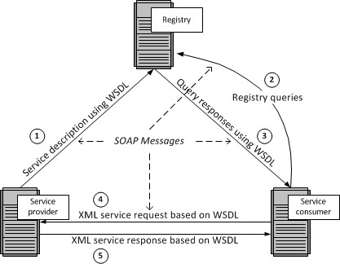

Service provider host a web service and upload the service description using Web Service Description Language (WSDL) to a registry containing a list of WDL files. WSDL is an XML based language used to describe capabilities and locations of services or in simply how to work with the web service. WSDL uses Simple Object Access Protocol (SOAP) as its communication protocol. SOAP is a framework which support exchange XML based information in a network environment. SOAP is a wrapper class which encapsulates XML based information within HTTP packets in order to send through internet.

Service consumers will search the registry for available web services. Registry is a list of web services from different service providers. It uses the UDDI technology for maintaining the registry. UDDI stands for Universal Description, Discovery and Integration. This provides a platform independent, XML- based registry mechanism between the server and client in order to situate each other. SOAP is used as the communication protocol used by the UDDI.

AS the diagram indicates the once the relevant web service is found, registry will respond with the necessary WSDL files. Using the information in those files service consumer will be able to use the services provided by the provider.

The main advantage of using web services is it allow different applications from different sources to communicate with each other without time-consuming custom coding. Web services do not depend on any one operating system or programming language. They are platform independent because all communication is done using XML. Apart from that using web services help to tighten the security of your data and system since when accessing through a web service, external parties do not have the direct access to companies system or database.

References

w3schools 2104, *Introduction to Web Services*, Viewed 9th December 2014

<http://www.w3schools.com/webservices/ws_intro.asp>

Barry D., K. n.d*, Web Services Explained,* Viewed 9th December 2014

http://www.service-architecture.com/articles/web-services/web_services_explained.html